Welcome to Leeds Atheist Society 2010/11!
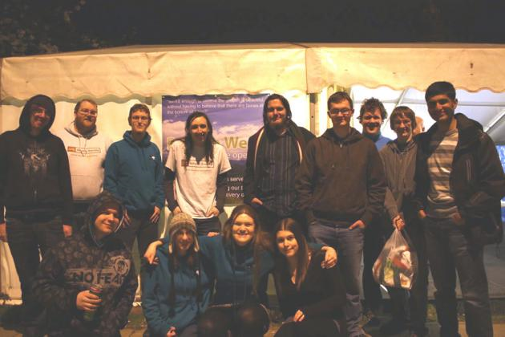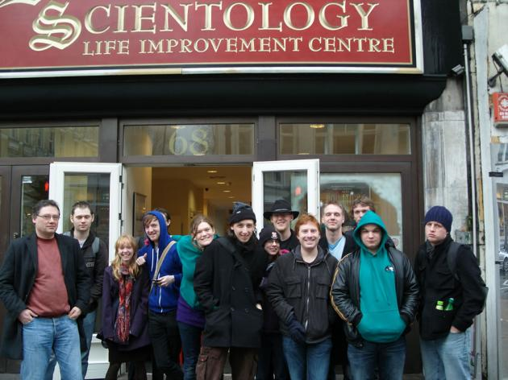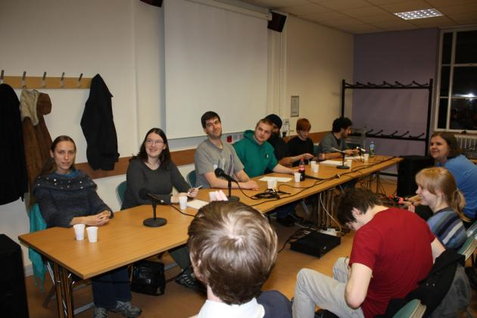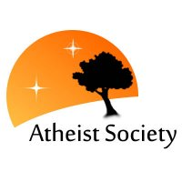
What’s Coming Up? (Dates for your Diary!)
We have some fantastic events lined up which we’re all very excited about! There will be talks, given by experts, on Freedom of Speech and Protection of Religious Beliefs (12th October), The Extra-terrestrial Origins of Life on Earth (23rd November). We host many Interfaith events such as Interfaith Panel (9th November), a debate on Ethics and Islam (30th November), one not to be missed is our Charity Quiz Night (2nd November), last year we raised over £100 in two hours for Amnesty UK. The One Life course will be running every Friday from 31st September. There is also our weekend away in Edinburgh (26th-28th November); previous trips have been enjoyed by all and we’re expecting more of the same this year!
This great program of events kicks of with our Intro Meeting followed by Karaoke and cocktails at D-Fusion on Tuesday 28th September in the Union Building meeting room ? @ 7pm-See you there!
Contact Us and Useful Links
For more information contact us via any of the following…
Website: http://leeds.atheistsoc.org/
Sign up at: www.leedsuniversityunion.org.uk/clubsandsocieties/faithandculture/Atheist/
Emai: leeds@atheistsoc.org
Facebook: Leeds Atheist Society (group)



